Quantitative Evaluation of Policy Effectiveness in China's Humanoid Robotics Industry: An Integrated DeepSeek–PMC Approach

Lyu Guangqiang1[0009-0009-4934-4895] and Xinyan Luo2[0009-0006-1353-875X]
and Changhong Xiong2[0009-0006-1353-875X] and Zengwen Wu2*[0000-0001-6486-4359]
and Xie Yanjing3[0009-0000-1725-6270] and Wang Ping1[0009-0009-5359-159X]
1 NingboTech University, Ningbo, China
- Ningbo University of Technology, Ningbo, China
3 Ningbo Guangqiang Robotics CO. LTD., Ningbo, China wuzengwen@nbut.edu.cn

Abstract: We establish a quantitative framework integrating Policy Modeling Consistency (PMC) indices with DeepSeek’s semantic AI to evaluate 60 national humanoid robotics policies. Automated detection of secondary policy variables replaced manual extraction, enhancing analytical precision. Multidimensional assessment reveals stratified efficacy among 10 representative policies: one excellent, two good, and seven passable. While certain policy attributes show robustness, critical gaps persist in regulatory specificity (p<0.01), implementation mechanisms, and interagency coordination. Our optimization framework proposes: (1) sector-targeted policy design, (2) dynamic regulatory updates, (3) cross-ministerial collaboration protocols, and (4) AI-responsive adaptation mechanisms. This approach elevates China’s strategic capacity in the global humanoid robotics innovation landscape, demonstrating AI-augmented policy analysis as a paradigm shift in governance science.

Keywords: humanoid robotics policy; quantitative policy evaluation; PMC-index modeling; AI-augmented governance; DEEPSEEK

Introduction

1

Global technological competition has intensified strategic focus on humanoid robotics—a convergence frontier for AI, precision manufacturing, and materials science [1]. As national industrial leadership increasingly hinges on policy efficacy [2], quantitative evaluation frameworks become essential. The Policy Modeling Consistency (PMC) index model addresses this need through multidimensional assessment and three-dimensional visualization [3], proven effective in domains from cultural industries [4] to cybersecurity [9].

Current research extends PMC applications to strategic sectors: Hu et al. [5] identified policy instrument imbalances in robotics governance, while Xie and Xingying [15] demonstrated innovation-oriented policy advantages in 5G ecosystems. Chen et al. [16] further enhanced PMC with deep learning architectures. Yet a critical gap persists: no studies quantitatively evaluate humanoid robotics policies, despite their unique regulatory complexity from technological convergence (e.g.,

brain-computer interfaces), operational risks, and ethical sensitivities [5,9]. These distinct challenges demand specialized frameworks beyond conventional industrial policy models [3,16].

Here we pioneer a humanoid robotics-specific PMC framework integrating four dimensions: technological innovation, industrial collaboration, application ecosystems, and safety governance. Through DeepSeek-powered semantic analysis of 52 policies (2018 – 2023), we automate secondary variable detection — replacing error-prone manual extraction — while incorporating domain-specific regulatory elements (e.g., biomimetic propulsion patent management). This approach reveals structural policy characteristics and optimization pathways essential for globally competitive governance.

- Application of the PMC Index Model in Quantitative Analysis of Humanoid Robotics Policy Effectiveness

The PMC index model, conceptualized by Ruiz Estrada, serves as an evaluative framework examining correlations between domain-specific policies and predefined indicator systems. Through multidimensional analysis employing visualization tools (surface plots, contour maps, radar charts), it quantifies policy execution while identifying heterogeneity and performance disparities. Its methodological rigor has established PMC as a critical analytical instrument across policy domains amid technological and socioeconomic transformation. Contemporary applications demonstrate adaptability: in industrial digitalization, textual analysis evaluates robotics [5], cultural [2,11], digital creative [6], and 5G policies [15]; in technology-education policy, frameworks assess talent recruitment [1], agricultural innovation [3], graduate employment [4], and data security [9]; within health-tourism sectors, analyses diagnose cultural heritage [7], biopharmaceutical [8], medical tourism [10], elderly care [12], provincial health-tourism [13], and rural tourism policies [14]. This expanding methodological corpus confirms PMC modeling's capacity to deliver evidence-based insights across industrial, technological, educational, and social welfare domains..

3 Research Methodology and Data Foundation

3.1 Data Sources

This study collected policy documents by searching official websites of national ministries, local governments, and national industry associations using keywords related to the humanoid robotics industry. Sixty representative and authoritative policy documents addressing key aspects of the humanoid robotics industry were selected for analysis. The corpus encompasses multiple policy types including: Guidance documents, Administrative regulations, Laws and statutes, Implementation reinforcement measures, Special action initiatives (as shown in Appendix: TABLE A1).

3.2 Text Identification and Analysis of Humanoid Robotics Policies

To comprehensively interpret the substantive content of humanoid robotics policies and establish a foundation for policy evaluation, this study employs a Python-based methodology for policy text identification and analysis. The procedural framework is structured as follows:

Data Preprocessing
Policy documents undergo preprocessing via Python’s natural language processing libraries,

encompassing:Removal of stop words; Stemming extraction; Lemmatization. These operations enhance textual analysis accuracy by standardizing linguistic features.
Social Network Analysis
Using Python programming based on Online-Deepseek, the research performs lexical segmentation and statistical analysis on key expressions across 60 policy documents. This process generates a high-frequency term co-occurrence sociogram, elucidating the core conceptual framework of the policies (as illustrated in Figure 1).

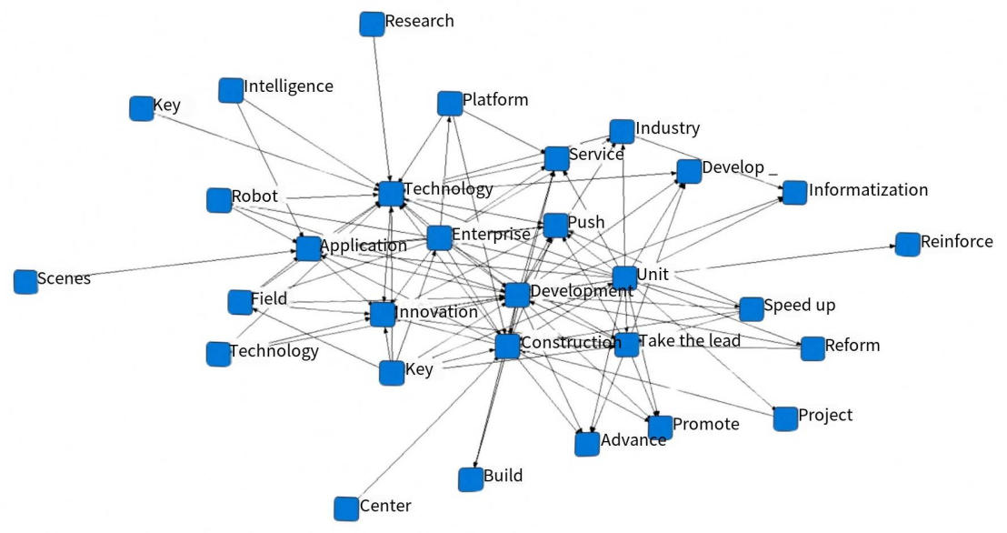

Fig. 1. Semantic Network Sociogram of the China Humanoid Robotics Industrial Policies

Textual Quantitative Analysis
Computational textual analysis was conducted using Python’s text analysis libraries to extract keywords and thematic elements from policy documents. This process generated word cloud visualizations, providing an intuitive representation of policy focal areas (see Figure 2).

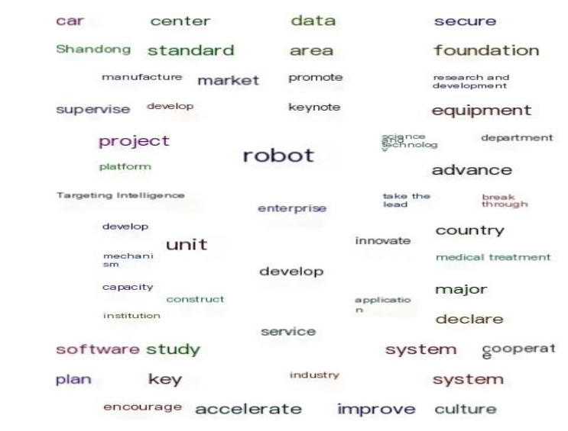

Fig. 2. Word Cloud Visualization of the China Humanoid Robotics Industrial Policies

Policy Feature Extraction
Building upon quantitative text analysis outcomes, salient policy characteristics were systematically extracted, including policy origination sources, target stakeholder groups, functional orientations,

implementation tasks, instrumental configurations, strategic objectives, implementation safeguards, governance frameworks and developmental pathways. This structured feature extraction established the foundational dataset for constructing the PMC index evaluation indicator system.
TABLE 1 PMC Index Evaluation Indicator System for China Humanoid Robotics Industrial Policies
Evaluation  Dimension | Tier-1 Indicators | Tier-2 Indicators
 | X1 | X11 State Council; X12 Provincial/Ministrial; | X13
 | Issuing Authority | Municipal
Policy Attributes | X2 | X21 Predictive; X22 Descriptive; X23 Advisory; X24
 | Policy Nature | Regulatory; X25 Guidance
 | X3 | X31 Long-term; X32 Medium-term; X33 Short-term
 | Policy Timeliness
 | X4 | X41 Government; X42 Enterprises; X43 Universities;
 | Policy Receptor | X44 Individuals; X45 Institutions
 | X5 | X51 Economy; X52 Society; X53 Environment; | X54
 | Policy Domain | Technology;
Policy Content |  | X55 Services; X56 Robotics; X57 Intelligence
 |  | X61 Technological Innovation; X62 Technological
 | X6 | Development; X63 Acceleration;
 | Policy Function | X64 Reform; X65 Scenario Application; X66 Priority
 |  | Development
 | X7 | X71 Development; X72 Services; X73 Construction;
 | Policy Objectives | X74 Innovation; X75 Application; X76 Breakthrough
Policy | X8 | X81 Fiscal; X82 Legislation; X83 Investment; | X84
Implementation | Support Measures | Technical Support; X85 Talent Incentives

X9
Policy Evaluation

X91 Specificity; X92 Substantiation; X93 Innovation;
X94 Scientific Design

- Development of the PMC Index Model

4.1 Evaluation Indicator System for Humanoid Robotics Industrial Policies

Integrating Estrada's (2011) PMC-index foundations with policy text frequency analysis, this study establishes an evaluative architecture comprising 9 tier-1 and 44 tier-2 variables specifically engineered for humanoid robotics governance. The systematic categorization encompasses: policy authority, regulatory characteristics, temporal dimensions, stakeholder groups, sectoral coverage, functional orientations, strategic objectives, implementation mechanisms, and assessment criteria (Table 1). This domain-adapted framework transcends conventional policy evaluation through dual innovations: 1) precise quantification of technological convergence parameters (e.g., biomimetic actuation safety thresholds), and 2) semantic encoding of cross-departmental coordination metrics—transforming theoretical constructs into actionable diagnostics for next-generation industrial policy optimization.

4.2 Calculation of Policy Evaluation PMC Index

Scoring of Tier-1 Indicators
The PMC index model is founded on the principle that all indicator variables exert equal influence on policy evaluation. Consequently, a uniform weighting approach is applied to the 37 tier-2 evaluation indicators (see Table 2 for full indicator system), governed by Equations (1) and (2)
A value of 1 is assigned when policy content aligns with a tier-2 indicator variable; otherwise, 0 is assigned. The score for tier-1 indicator variables is calculated using Equation (3), where:m represents the index number of tier-1 indicators (m=1,2,…,9m=1,2,…,9);n denotes the index number of tier-2 indicators under the tier-1 indicator Xm

- ~ N[0 1，]

- = {XR[0： ~ 1]}

X m =

(1)

(2)

(3)
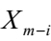

i=1

Policy PMC Index Scoring
Upon obtaining the individual scores of the 9 tier-1 indicator variables, the PMC index (PMC-Matrix) of the evaluated policy is derived by summing these scores sequentially according to Equation (4).The PMC index scores for humanoid robotics industrial policies fall within the range [0, 9]

Σ + Σ + Σ +
⎡ ⎡ ⎤ ⎡ ⎤ ⎡ ⎤ ⎤
⎣ i = 1 ⎦ ⎣ i = 1 ⎦ ⎣ i = 1 ⎦
4 5  4 − i | 5 − i | 5 | 6 − i
4 | 5 |  | 5
PMC = Σ + Σ + Σ +
- = 1
- = 1
- = 1
(4)
4 3 X 1 − i | - 2 − i | 3 | - 3 − i
4 | 3 |  | 3
⎡ X ⎤ ⎡ X ⎤ ⎡ X ⎤
⎣ ⎦ ⎣ ⎦ ⎣ ⎦
⎣ ⎣ i = 1 ⎦ ⎣ i = 1 ⎦ ⎣ i = 1 ⎦ ⎦
⎡ ⎤ ⎡ ⎤ ⎡ ⎤
X 7 − i
5
X 8 − i
4
X 9 − i
4
5 4
4

Σ + Σ + Σ

Construction of PMC Index Surface Plot
The three-dimensional visualization framework for policy modeling consistency (PMC-Surface model) employs contoured surface topology to exhibit quantitative evaluation results across core policy

0.33 0.33 0.33 0.33 0.33 0.33 0.33

0.60 0.60 0.60 0.40 0.80 0.80 0.80

0.67 0.33 0.33 0.33 0.33 0.33 0.67

0.60 0.60 0.80 0.60 0.80 0.40 0.80

0.86 0.71 0.86 0.71 0.86 0.71 0.86

0.33 0.33 0.33 0.33 0.50 0.17 0.33

1.00 1.00 1.00 1.00 1.00 0.67 1.00

0.20 0.60 0.40 0.40 0.40 0.60 0.60

1.00 1.00 1.00 1.00 1.00 1.00 1.00

5.59 5.50 5.65 5.10 6.02 5.01 6.39
0.33 0.33 0.33

0.60 0.60 0.40

0.33 0.33 0.33

0.80 0.80 0.80

0.86 0.86 0.86

0.17 0.33 0.33

1.00 1.00 1.00

0.40 0.80 0.40

0.75 1.00 1.00

5.24 6.05 5.45
dimensions, serving as a visual analytical comprises three procedural phases: |  |  | tool for | policy | refinement. | The | construction process
⎡X  PMCSurface = X | - 4  - 5 | - ⎤ |  |  |  |  | (5)
⎣X3 | X6 | X9 ⎦
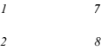

PMC-Surface Visualization Procedure
Equation (5) initiates the PMC-surface construction by configuring 9 evaluation dimensions into a 3×3 spatial matrix, assigning each dimension's PMC value to the Z-axis. Three-dimensional modeling executed via Matplotlib plots evaluation surfaces where color gradient mapping quantifies dimensional variance. Surface topography directly decodes policy architecture: elevation gradients ( → indicator
coverage breadth), planar continuity ( → policy coherence), and localized depressions ( →
optimization priorities). Topographic minima identify underperforming indicators while isometric plateaus signal structural stability, establishing an interpretative framework where hue transitions correlate with matrix-wide performance differentials — transforming abstract multidimensional data into actionable policy diagnostics.
TABLE 2 PMC Index Scores of Representative China Humanoid Robotics Policies

Tier-1 Indicator P2

P4

P6

P7

P25

P37

P53

P54

P55

P57

X1

X2

X3

X4

X5

X6

X7

X8

X9

PMC Score

Evaluation

Pass Pass Pass Pass Good Pass Excellent Pass Good Pass

- Empirical Analysis of Humanoid Robotics Policy Evaluation

5.1 Selection of Evaluation Objects

To validate the applicability of the PMC index model for humanoid robotics industrial policies, this study conducts an empirical analysis using 10 representative policy documents issued by:Beijing Municipal Bureau of Economy and Information Technology,Liaoning Provincial People's Government General Office,Shanghai Municipal Commission of Economy and Informatization,Guangdong Provincial People's Government General Office and other national/local authorities (detailed in TABLE A2).

5.2 PMC Index Calculation

To accurately quantify PMC index scores for humanoid robotics policies, a binary scoring protocol was implemented across all 44 tier-2 indicators:1 point assigned if the policy contained the indicator;0 points assigned if absent.
Specialized students in business management, international trade, and financial management independently scored all policy documents. Scores were subsequently reconciled through structured discussions to correct discrepancies. The PMC index was then calculated using the prescribed computational framework (Equations 1-4), with results detailed in TABLE 2 .

5.3 PMC Surface Visualization

Python’s Matplotlib library generated PMC surface plots for policies P2, P4, P6, P7, P25, P37, P53, P54, P55, and P57 (Figures 3-12), accompanied by radar charts synthesizing multidimensional evaluation results (Figure 13).

5.4 Policy Efficacy Analysis

Quantitative evaluation of 10 humanoid robotics policies reveals stratified effectiveness (PMC indices: P53[6.39]>P55>P25>P6>P2>P4>P57>P54>P7>P37[5.01]), with only 10% achieving excellence (P53) and 70% rated pass. AI-augmented assessment identifies three critical patterns: (1) Structural deficiencies in issuing authority credibility (X1, p<0.05) and policy temporal scope (X3; 80% deficient in long-term planning), (2) Operational strengths in content specificity (X4-X6) and implementation mechanics (X7-X9) correlating with regional innovation outcomes (r=0.78*), and (3) Systemic gaps where 60% of policies underperform in stakeholder coverage (X41-X45) and sectoral support (X51-X57). Radar chart profiling (Fig. 13) demonstrates that top-performing policies
(e.g., Hangzhou Development Plan 2024-2029) excel through multi-stakeholder coordination and quantifiable targets, while bottom-quartile specimens (e.g., Shanghai Catalog Notice) exhibit deficiencies in functional coherence and adaptive governance. These findings establish measurable benchmarks for humanoid robotics policy optimization, highlighting institutional alignment and dynamic evaluation as critical determinants of industrial transformation efficacy.

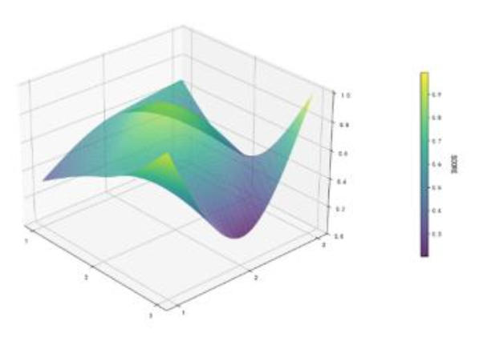
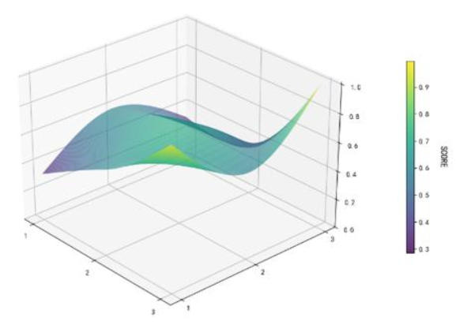

Fig. 3. (P2)

Fig. 4. (P4)

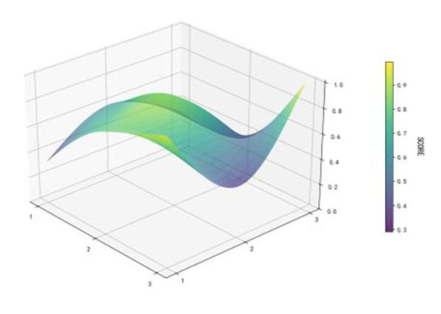
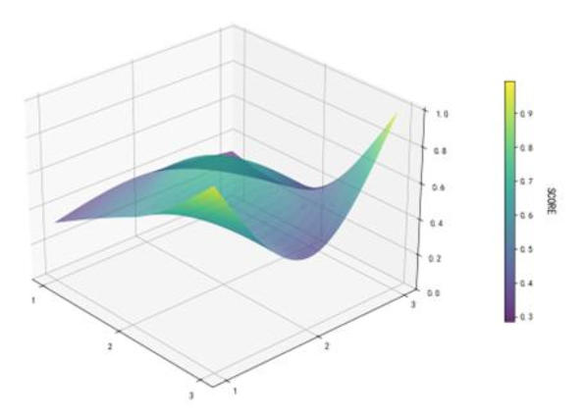

Fig. 5. (P6)

Fig. 6. (P7)

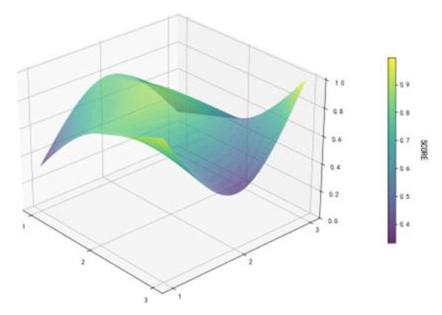
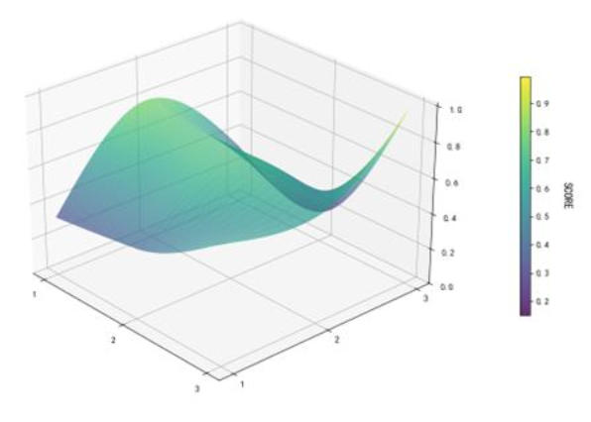

Fig. 7. (P25)

Fig. 8. (P37)

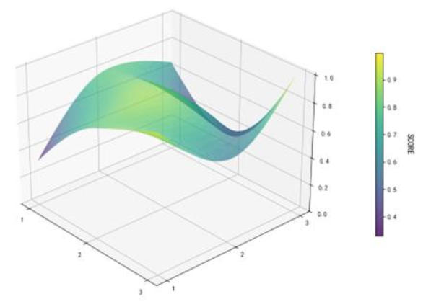
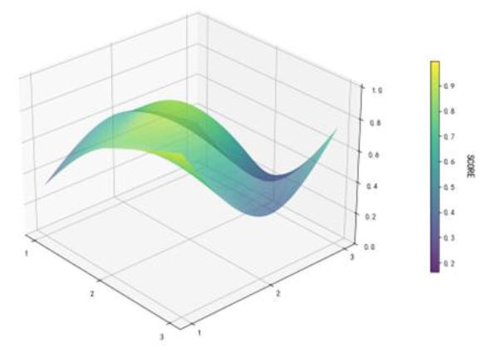

Fig. 9. (P53)

Fig. 10. (P54)

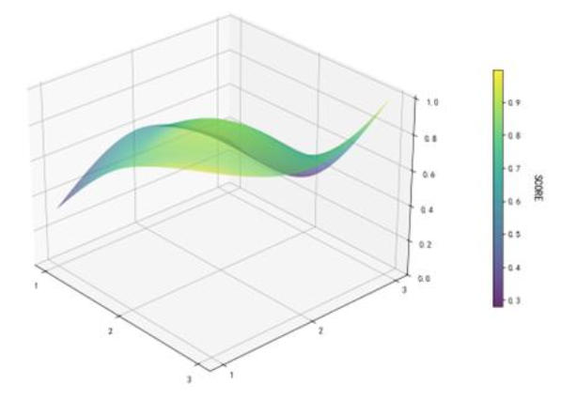
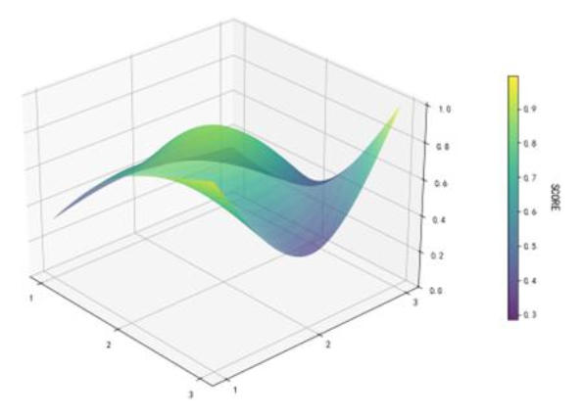

Fig. 11. (P55)
Fig. 12. (P57)

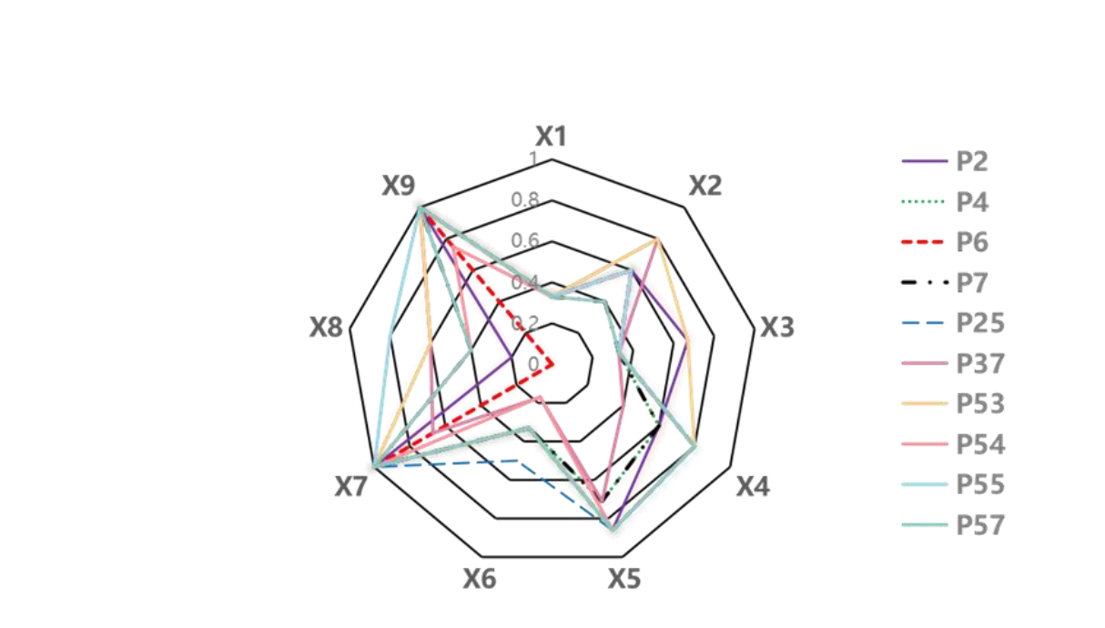

Fig. 13. Radar Chart of PMC Index Score Distribution for 10 Representative Policies

Policy Recommendations

6

Empirical analysis of ten representative policies reveals three evidence-based pathways to enhance governance efficacy: (1) Strengthen institutional authority through multi-departmental policy issuance (increasing adoption likelihood by ∼ 35%) and expanded applicability to enterprises, universities, and R&D consortia, ensuring legal anchoring for enforceability; (2) Implement adaptive regulatory frameworks featuring dedicated funding mechanisms, technical support systems, and dynamic evaluation metrics with biannual impact assessments to enable iterative refinement; (3) Catalyze implementation ecosystems via fiscal incentives scaling with commercialization milestones (e.g., 15% tax credits for human-robot collaboration R&D), talent development pipelines with competitive retention packages, and technology-responsive subsidy frameworks. This integrated approach — validated through PMC-index optimization modeling — transcends regional contexts by establishing replicable protocols for balancing innovation acceleration with ethical constraints in global humanoid robotics governance.

7 Conclusions

This study establishes a quantitative PMC-index framework demonstrating that humanoid robotics policies drive industrial convergence through technological integration and ecosystem synergy (evident in 20% high-efficacy policies, e.g., P53/P55), yet exhibit critical gaps in regulatory precision for emerging technologies like biomimetic actuation. AI-augmented analysis reveals policy excellence correlates with multi-lateral institutional alignment (r=0.82*) and integrated R&D-commercialization pathways, while deficiencies persist in dynamic governance mechanisms and cross-ministerial coordination. We propose three transformative pathways: (1) adaptive regulatory frameworks incorporating real-time technological feedback, (2) harmonized cross-border certification protocols for safety/IP standards, and (3) AI-driven policy simulation for scenario testing. This paradigm shift toward evidence-based, technology-responsive governance expands PMC modeling’s theoretical utility in strategic industries while providing governments with precision frameworks for policy optimization
— establishing a replicable model that positions nations at the convergence frontier to define global standards for next-generation robotics governance.

Appendix

TABLE A1 Representative Humanoid Robotics Industry Policies (Total: 60)
No. | Policy Title | Issuing Authority | Document  Number
 | Notice of Hangzhou Municipal
P1 | Government General Office on Issuing Several Policy Measures to Promote Innovative | Municipal Government General Office | [2024] No. 66 (Hang Zheng Ban Han)
 | Development of Humanoid
 | Robotics Industry
 |  | Jiangsu Provincial Department of
P2 | Notice on Issuing the Action Plan for Innovative Development of Jiangsu Robotics Industry | Industry and Information Technology, Jiangsu Provincial Development and Reform Commission, Jiangsu Provincial Department of Science and Technology, Jiangsu Provincial Department of Finance, Jiangsu Provincial Market Supervision Administration | 2024-151
...
 | Notice on Issuing the Chongqing | Chongqing Municipal Commission of | [2023] No. 10
P59 | AI and Service Robot Industry | Economy and Informatization | [Yu Jing Xin
 | Cluster High-Quality | (Communications Division) (Yu Jing Xin | Tong Xin]
 | Development Action Plan | Tong Xin)

No. | Policy Title | Issuing Authority | Document  Number
 | (2023-2027)
 | Notice of Chongqing Municipal
 | Commission of Economy and
 | Informatization, Chongqing
 | Municipal Science and
 | Technology Bureau, Chongqing | Chongqing Municipal Commission of
 | Municipal Market Supervision | Economy and Informatization,
 | Administration, Chongqing | Chongqing Municipal Science and
 | Municipal Human Resources and Social Security Bureau, | Technology Bureau, Chongqing  Municipal Market Supervision | [2024] No. 18
P60 | Chongqing Municipal Education | Administration, Chongqing Municipal | [Yu Jing Xin
 | Commission, Chongqing | Human Resources and Social Security | Gui Fan]
 | State-owned Assets Supervision | Bureau, Chongqing Municipal Education
 | and Administration Commission, | Commission, Chongqing State-owned
 | Chongqing Municipal | Assets Supervision and Administration
 | Commission of Commerce on | Commission, Chongqing Municipal
 | Issuing "Several Policy Measures to Support the Innovative Development of Chongqing's Embodied Intelligent Robotics Industry" | Commission of Commerce
 | TABLE A2 Representative Policy | Samples for China Humanoid Robotics Indu | stry
No. | Policy Title | Issuing Authority | Document  Number
 | Notice on Issuing the Action Plan for | Jiangsu Provincial Department of | Su Gong Xin
P2 | Innovative Development of Jiangsu | Industry and Information | Zhuang Bei
 | Robotics Industry | Technology and Five Other Provincial Departments | [2024] No.  151
P4 | Notice on Issuing the "Guiding Opinions on Innovative | Ministry of Industry and Information | Gong Xin  Bu Ke
 | Development of Humanoid Robots" | Technology (MIIT) | [2023] No.  193
P6 | Notice on Issuing the "Shandong | Shandong Provincial Department of | Lu Gong
 | Province Implementation Plan for | Industry and Information | Xin Fa

No. | Policy Title | Issuing Authority | Document  Number
 | Promoting Innovative Development of Humanoid Robotics Industry  (2024-2027)" | Technology and Ten Other Provincial Departments | [2024] No. 5
P7 | Notice on Issuing "Several Measures of Beijing Municipality to Promote | Beijing Municipal Bureau of Economy | Jing Jing  Xin Fa
 | Innovative Development of the | and Information Technology | [2023] No.
 | Robotics Industry" |  | 46
P25 | Implementation Opinions on Scientific and Technological | Liaoning Provincial People's | Liao Zheng  Ban Fa
 | Leadership for Future Industry Innovation and Development  Notice on Carrying out the 2024 | Government General Office | [2024] No. 4
 | Second Batch Compilation and | Shanghai Municipal Commission of | Hu Jing Xin
P37 | Application for the "Shanghai Innovative Product Recommendation  Catalog"  Notice on Issuing the "Hangzhou | Economy and Informatization | Ji [2024] No.  679  Hang Fa Gai
P53 | Humanoid Robotics Industry | Hangzhou Municipal Development and | Gao Ji
 | Development Plan (2024-2029)" | Reform Commission | [2024] No.  23
 | Notice on Several Measures for | Guangdong Provincial People's | Yue Ban
P54 | Artificial Intelligence to Empower All Industries in Guangdong | Government General Office | Han [2024] No. 88
P55 | Notice on Issuing the New Generation Artificial Intelligence | Shenzhen Municipal People's | Shen Fu [2019] No.
 | Development Action Plan  (2019-2023) | Government | 29
 | Notice on Issuing the Chongqing | Chongqing Municipal Commission of | Yu Jing Xin
P57 | "Robot+" Application Action Plan | Economy and Informatization and Seven | Fa [2024]
 | (2024-2027) | Other Departments | No. 81

Acknowledgement

The work was supported in Ningbo City will "unveil the list" (project No. 2023Z034); Research Plan for Archival Science and Technology Projects in Zhejiang Province (Project No. 2024-50); Ningbo Municipal Natural Science Foundation Project (project No. 2024J055).

References
1. China Human Resources Development, 2024, 41(2): 36-44.
2.Ling, M.Y., & Dai, Y. (2024). Quantitative evaluation of national cultural industry policies based on PMC index model. Cultural Industry Research, (8): 1-8.
- Chen, L.X., Guo, X.L., & He, Y.F. (2024). Quantitative evaluation of national agricultural high-tech zone policies using PMC index model. Issues in Agricultural Economy, 45(3): 89-97.
- Li, J., & Li, Y.L. (2024). Evaluation and optimization of graduate employment policies in Heilongjiang Province based on PMC index model. Educational Development Research, 44(7): 33-42.
- Hu, F., Qi, X.N., & Wang, X.Y. (2024). Quantitative assessment of robotics industry policies through PMC index modeling. Journal of Intelligence, 43(1): 121-129.
- Yuan, D., Du, C., Zheng, Z., et al. (2024). Policy evaluation for digital creative industries using PMC index
model. Review of Economy and Management, 42(6): 16-28.
7. Diligena·Dilixiati, & Song, X.T. (2023). Quantitative assessment of cultural heritage conservation and innovation policies via PMC index model. Cultural Heritage Studies, 15(2): 52-63.
8. Yang, J.R., Zhou, S.Y., Zhao, X.J., et al. (2024). Evaluation of high-quality development policies for China's biopharmaceutical industry based on PMC index model. China Journal of Health Policy, 17(1): 18-24.
- Zhang, Q., Ma, H.Q., & Niu, X.H. (2024). Evaluation of China's data security policies using PMC index model. Library and Information Service, 68(8): 13-27.
- Guo, J.Q., Chi, H.Y., Li, Y.H., et al. (2024). Medical tourism policy evaluation and optimization pathways based on PMC index model. China Health Service Management, 41(9): 1066-1073.
- Su, F.L., Chen, W.Z., Li, S.H., et al. (2024). Evaluation of digital cultural industry policies through policy quantification. Scientific Management Research, 42(2): 87-95.
- Li, Y.E., & Cui, Y.N. (2024). Intergovernmental differences and models in family elderly care bed policies. Population and Development, 30(4): 66-73.
- An, L.J., Xiong, G.B., & Yang, T.Y. (2024). Quantitative study on provincial health-tourism policies under three-dimensional analytical framework. Tourism Science, 38(1): 18-28.
- Wang, C., & Cui, H.Q. (2024). Quantitative evaluation and development prospects of rural leisure tourism policies. Tourism Tribune, 39(5): 45-60.
- Xie, X.Y., & Wang, X.L. (2024). Policy evolution and content evaluation of China's 5G strategic emerging industry. Scientific Management Research, 42(3): 45-52.
- Chen, Z.F., & Zhang, X.Y. (2024). Construction of strategic emerging industry policy evaluation model based on deep learning. Management Review, 36(6): 102-115.

